Exception Hierarchy

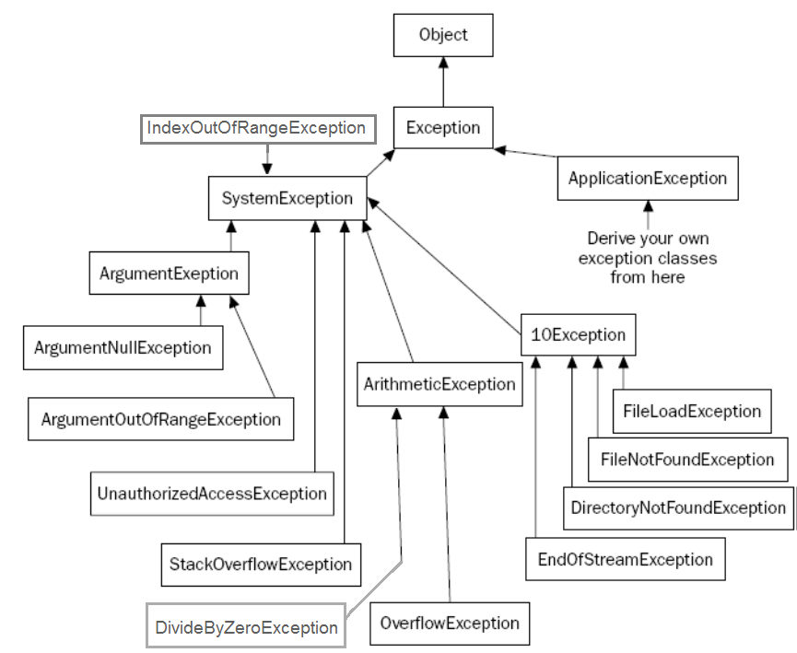

|  |  |
| --- | --- |
| Exception Class | Description |
| [ArgumentException](https://docs.microsoft.com/en-us/dotnet/api/system.argumentexception?view=netframework-4.8) | Raised when a non-null argument that is passed to a method is invalid. |
| [ArgumentNullException](https://docs.microsoft.com/en-us/dotnet/api/system.argumentnullexception?view=netframework-4.8) | Raised when null argument is passed to a method. |
| [ArgumentOutOfRangeException](https://docs.microsoft.com/en-us/dotnet/api/system.argumentoutofrangeexception?view=netframework-4.8) | Raised when the value of an argument is outside the range of valid values. |
| [DivideByZeroException](https://docs.microsoft.com/en-us/dotnet/api/system.dividebyzeroexception?view=netframework-4.8) | Raised when an integer value is divide by zero. |
| [FileNotFoundException](https://docs.microsoft.com/en-us/dotnet/api/system.io.filenotfoundexception?view=netframework-4.8) | Raised when a physical file does not exist at the specified location. |
| [FormatException](https://docs.microsoft.com/en-us/dotnet/api/system.formatexception?view=netframework-4.8) | Raised when a value is not in an appropriate format to be converted from a string by a conversion method such as Parse. |
| [IndexOutOfRangeException](https://docs.microsoft.com/en-us/dotnet/api/system.indexoutofrangeexception?view=netframework-4.8) | Raised when an array index is outside the lower or upper bounds of an array or collection. |
| [InvalidOperationException](https://docs.microsoft.com/en-us/dotnet/api/system.invalidoperationexception?view=netframework-4.8) | Raised when a method call is invalid in an object's current state. |
| [KeyNotFoundException](https://docs.microsoft.com/en-us/dotnet/api/system.collections.generic.keynotfoundexception?view=netframework-4.8) | Raised when the specified key for accessing a member in a collection is not exists. |
| [NotSupportedException](https://docs.microsoft.com/en-us/dotnet/api/system.notsupportedexception?view=netframework-4.8) | Raised when a method or operation is not supported. |
| [NullReferenceException](https://docs.microsoft.com/en-us/dotnet/api/system.nullreferenceexception?view=netframework-4.8) | Raised when program access members of null object. |
| [OverflowException](https://docs.microsoft.com/en-us/dotnet/api/system.overflowexception?view=netframework-4.8) | Raised when an arithmetic, casting, or conversion operation results in an overflow. |
| [OutOfMemoryException](https://docs.microsoft.com/en-us/dotnet/api/system.outofmemoryexception?view=netframework-4.8) | Raised when a program does not get enough memory to execute the code. |
| [StackOverflowException](https://docs.microsoft.com/en-us/dotnet/api/system.stackoverflowexception?view=netframework-4.8) | Raised when a stack in memory overflows. |
| [TimeoutException](https://docs.microsoft.com/en-us/dotnet/api/system.timeoutexception?view=netframework-4.8) | The time interval allotted to an operation has expired. |

Exception class members:

Properties

* **Message**
  + Gets a message that describes the current exception.
* **Source**
  + Gets or sets the name of the application or the object that causes the error.
* **StackTrace**
  + Gets a string representation of the frames on the call stack at the time the current exception was thrown
* **TargetSite**
  + Gets the method that throws the current exception.
* **HelpLink**
  + Gets or sets a link to the help file associated with this exception
* **InnerException:** holds a reference to the previous exception

https://learn.microsoft.com/en-us/dotnet/standard/design-guidelines/using-standard-exception-types